When branch/dealer/user info is updated, we will keep original record of history purpose so we can go back and see what all changes were made.

When branch/dealer/user is deleted we will not actually remove data but we will use deleted flag so its data will be with us.

**For Line Chart,**

Time Period What to display on X-axis

Last 7 Days Last 7 dates (so there will be 7 data points)

Last 15 Days 7-8 dates (display alternate dates and 15 data points)

Last Month 4-5 dates (display all dates which falls on Monday, but range will start from 1st to last day of the month)

Last 3 month 6-7 dates (display date of alternate Monday in last 3 months, but 90-92 data points)

Last 6 month 6 dates (first of every month, and all data points)

Custom Range We removes this option

**SUPER ADMIN (ADMIN)**

Dashboard default should be last 7 days.

Remove Gender from all the forms and lists

Change Pincode to zip code.

Zip code is 5 digit number. Currently you have validation for 6 digit.

**Menu**

In menu, we are using, default icon for home. Can we change it to actual home icon to make it easy.

**Add Dealer**

After selecting state, its keep spinning. Cannot select city and it cannot continue

Also, there is an overlapping text Above state Dropbox.

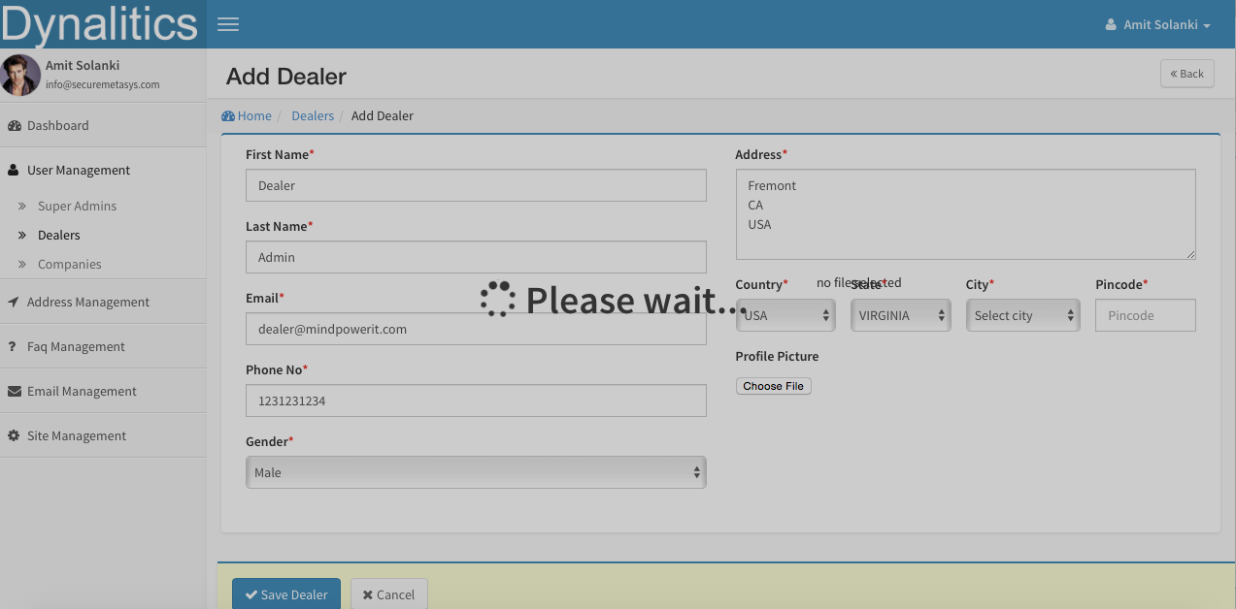

**Add Company**

Also, there is an overlapping text Above state Dropbox. (Same like above)

Company can be created without dealer (To avoid functionality change we can add another option none which will be default)

**Company List**

Missing Dealer (Dropdown) for searching.

Dealer listing page:

Country: Only USA

State: All states in USA

City: All Cities in USA

<http://www.farinspace.com/us-cities-and-state-sql-dump/>

<http://demo.securemetasys.com/dynalitics/dealers/add/24>

There is an overlapping text Above state Dropbox

We can remove column “[Total Sub Dealers](http://demo.securemetasys.com/dynalitics/dealers/index/sort:sub_dealer_count/direction:asc)”

<http://demo.securemetasys.com/dynalitics/dealers/index/Dealer:24>

Title should not be “Sub Dealer”, it should be “Dealer Users” and Breadcrumbshoud shows (Home / Dealer / Users)

Above “Displaying 1 - 2 of 2 total” we should display that “Dealer Name : [Dealer One]” and remove (Dealer One) from name column.

Top right corner we have button “Add Dealer” can we change it to “Add User” which means add user to the dealer

<http://demo.securemetasys.com/dynalitics/companies>

Table column title “Total Sub Company” should change “No of Branches”

Please make name column as link, so if user click on it, it will show company detail page. And remove “view company” from action

Please make dealer name column as link, so if user click on it, it will show dealer detail page.

On this page, we will only display main company account and no need to display type column. Consider company is a group.

When I move mouse over image in action column it shows,

Shows: Change To:

Click here to Edit this employee Edit Company

Click here to reset password Reset Password

Click here to delete this employee Delete Company

Click here to add dealer for this super dealer Add user to Company

Phone number should be formatted – (XXX) XXX – XXXX

<http://demo.securemetasys.com/dynalitics/companies/view/46>

Name will be contact name only (currently it shows company name + contact name)

Remove Gender

Email Address to Email

Phone need to be formatted

Change page title from “Company Detail” to “Company name”

On this page we can merge 2 other pages. So it will have 3 sections.

First section, company detail (currently what we have)

Second, all branches of this company

Third, all users under this company

Second and third section should be look like user list page for company. (With sorting and filtering functionality)

I was expecting something like this. This way we can do all maintenance from one page instead of having two separate pages.

<http://demo.securemetasys.com/dynalitics/companies/edit/46>

Overlapping text above state

<http://demo.securemetasys.com/dynalitics/companies/add/48>

Title should be “[Company Name] - Add Branch”

“Company Name” should be Branch Name

“Super Company” should be “Company Name”

Company type will be branch manager only.

Overlapping text above state

We need to have page for adding branch and adding user to company. (Dealer will have only user)

Branches can have different dealer.

<http://demo.securemetasys.com/dynalitics/dealers>

Please make name column as link, so if user click on it, it will show dealer detail page? And remove “view dealer” from action

When I move mouse over image in action column it shows,

Shows: Change To:

Click here to Edit this employee Edit Dealer

Click here to reset password Reset Password

Click here to delete this employee Delete Dealer

Click here to add dealer for this super dealer Add user to dealer

Phone number should be formatted – (XXX) XXX – XXXX

On this page, we will only display main dealer account and no need to display type column. Consider dealer is a group.

We can combine pages (Dealer detail and Dealer user listing) into one page. So have full page with all the details. So new page will have Top section with dealer detail and bottom will have user listing.

Second section should be look like user list page for dealer. (With sorting and filtering functionality)

I was expecting something like this. This way we can do all maintenance from one page instead of having two separate pages.

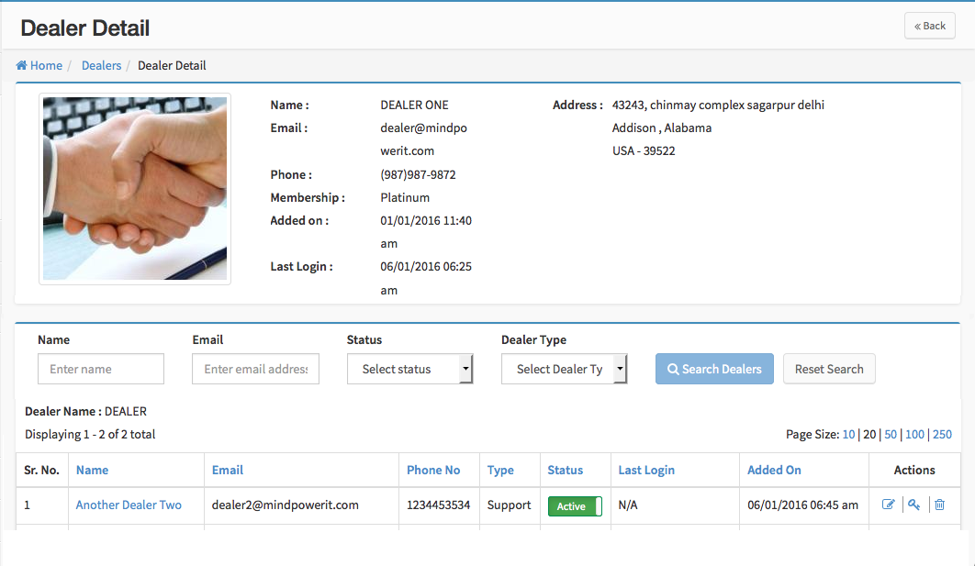

<http://demo.securemetasys.com/dynalitics/dealers/view/21>

Email Address: should be just “Email”,

Please add Phone

Please remove gender

Please make sure if larger image is uploaded as dealer profile then it will be displayed in small section only.

We should rearrange email address on right hand side or make left side larger so email will display in one line rather than two.

All Date must be in mm/dd/yyyy hh:mm am/pm format

Wrong spelling of country into Menu (Address Management)

**User Management🡪Super Admins:**

When super admin create another “support admin” then we need option to allow which dealer and company profile that support person can look at. That way we can allow support admin to not view all companies/dealers.

**Analytic Management🡪 File Processing View:**

We need to have filter for company.

By default it should show last 7 days data. Admin will change time range if required.

Graph should be longer in length.

For last 7 days there are no file processed. However in this case, we still need to show dates and Dark line at 0 No of files.

Time Period What to display on X-axis

Last 7 Days Last 7 dates (so there will be 7 data points)

Last 15 Days 7-8 dates (display alternate dates and 15 data points)

Last Month 4-5 dates (display all dates which falls on Monday, but range will start from 1st to last day of the month)

Last 3 month 6-7 dates (display date of alternate Monday in last 3 months, but 90-92 data points)

Last 6 month 6 dates (first of every month, and all data points)

Custom Range We removes this option

We need to show Pie Chart.

Pie chart will display how many file for each client for range.

We need to show data into tabular format also.

We need to add button for create pdf file of the screen and download it. When user click on this button, we will create PDF file on server and give popup message for user to download it.

Table Columns should be as follow: (Column should be sortable)

Sr No

Company Name

Branch

Date

No of time file processed

First process time

Last process time

**Analytic Management🡪 Transaction Details:**

We need to have filter for company.

By default it should show last 7 days data. Admin will change time range if required.

Graph should be longer in length.

For last 7 days there are no file processed. However in this case, we still need to show dates and Dark line at 0 No of files.

Time Period What to display on X-axis

Last 7 Days Last 7 dates (so there will be 7 data points)

Last 15 Days 7-8 dates (display alternate dates and 15 data points)

Last Month 4-5 dates (display all dates which falls on Monday, but range will start from 1st to last day of the month)

Last 3 month 6-7 dates (display date of alternate Monday in last 3 months, but 90-92 data points)

Last 6 month 6 dates (first of every month, and all data points)

Custom Range We removes this option

We need to show multiple Pie Charts.

Pie chart for how many transactionsfor each client for range.

Pie chart for transactions by categoryfor range

Pie chart for transactions by typefor range

Table Columns should be as follow: (Column should be sortable)

Sr No

Company Name

Branch Name

Date

Total Transactions

No of Deposits

No of Withdrawals

Total denom 1

Total denom 2

Total denom 5

Total denom 10

Total denom 20

Total denom 50

Total denom 100

Total Amount Requests

Total Amount Deposited

Total Amount Withdrawal

**Analytic Management🡪Error Details:**

This will shows number of error happened in period for all the clients.

We need to have filter for company.

By default it should show last 7 days data. Admin will change time range if required.

Graph should be longer in length.

For last 7 days there are no file processed. However in this case, we still need to show dates and Dark line at 0 No of files.

Time Period What to display on X-axis

Last 7 Days Last 7 dates (so there will be 7 data points)

Last 15 Days 7-8 dates (display alternate dates and 15 data points)

Last Month 4-5 dates (display all dates which falls on Monday, but range will start from 1st to last day of the month)

Last 3 month 6-7 dates (display date of alternate Monday in last 3 months, but 90-92 data points)

Last 6 month 6 dates (first of every month, and all data points)

Custom Range We removes this option

We need to show multiple Pie Charts.

Pie chart for error for each client for range.

Pie chart for error type for range

Table Columns should be as follow: (Column should be sortable)

Sr No

Company Name

Branch Name

Dealer Name

No of Events

Error Message

Date error occurred

Date time reported

Date time notification message

Date time Acknowledged

Date time Resolved

Dealer Support Engineer

**Analytic Management🡪 Inventory : Remove this.**

**Analytic Management🡪 Company: Add This one.**

This page will list all companies in system and for which user has access too.

Admin can filter company by state, city and search company name.

And when super admin or super admin support click on particular company, we open a new tab and in that tab, admin can view what company can view. So admin can help and investigate company’s question.

**Analytic Management🡪Dealers:Add This one.**

This page will list all companies in system and for which user has access too.

Admin can filter company by state, city and search company name.

And when super admin or super admin support click on particular dealer, we open a new tab and in that tab, admin can view what dealer can view. So admin can help and investigate dealer’s question.

**Billing**

This is future section. In future all payments will be automatic (bank transfer or credit card). So this section will display all received/pending payment for billing period and functionality to view past payments with information.

**Subscriptions**

This page we need to list all options of subscription available in system for dealer and company. From here we will allow admin to update what features are included into particular subscription plan and cost of it.

**FAQ Management**

From this section, super admin can create FAQs for Company and Dealer.

**Branch Management: Remove this.**

Branches will be managed from the company section only.

**COMPANY (ADMIN)**

Dashboard will not have “No of Transactions”

Dashboard default should be last 7 days.

Next to profile icon (top right corner), It looks like it shows company name and company admin name. We need to show only company admin name,

Below “Dynalitics” logo (top right corner), It looks like it shows company name and company admin name. We need to show only company name and title “company admin”.

<http://demo.securemetasys.com/dynalitics/companies>

Remove Dealer name from filter.

In table, we need to add column for user role. (if user role is branch admin and he has more than one branch associated with that user then display “Regional Admin”)

Add filter for user role.

We should make url more readable. Since this is user related we should make sure that it shows users in it. Companies at end looks weird. I think url should be like (<http://demo.securemetasys.com/dynalitics/company_name/users>)

In table, title “[Company Name](http://demo.securemetasys.com/dynalitics/companies/index/sort:first_name/direction:asc)” should be “User Name”

<http://demo.securemetasys.com/dynalitics/companies/add>

Company Name field need to removed.

We should remove “Address, Country, State, city and zip field”

Remove Membership, since this is company user, its not necessary.

Contact Name should be “User Name”

We should make url more readable. Since this is user related we should make sure that it shows users in it. Companies at end looks weird. I think url should be like (<http://demo.securemetasys.com/dynalitics/company_name/users>/add)

User type should be 1) Company Admin and 2) Branch Admin

If user type is selected to Branch admin then, we should display list of all branches of that company with checkboxes. Minimum one branch must be selected. Maximum all branches. (If more than one branch is associated then this we will display Region Admin instead on Branch Admin)

It look like there is Assign Branch at bottom but it is overlapped by “Save User and Cancel button”

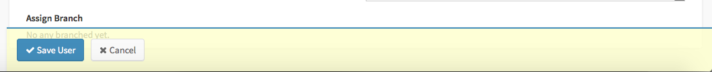

After above change please organize form fields so both side look good.

<http://demo.securemetasys.com/dynalitics/company_branches/add/0> and <http://demo.securemetasys.com/dynalitics/company_branches/edit/MTIwODI0ODAuNTI%3D>

FTP Username/password will be auto-generated and it wont be editable.

We should add optional dropdown for assign branch manager. This dropdown will have list of all the users in this company.

Address must be divided into two section: Address 1 and Address 2

Zip code field need to be added.

Any time new branch is created/edited/deleted all company must be notified.

When branch info is updated, we will keep original record of history purpose so we can go back and see what all changes were made.

When branch is deleted we will not actually remove data but we will use deleted flag so its data will be with us.

<http://demo.securemetasys.com/dynalitics/users/profile>

We should remove “Address, Country, State, city and zip field”

Profile picture upload is different from other sections. Profile shows:



Other pages shows:



**Analytics Management 🡪Transaction Details**

Line chart need to increase in size (horizontally)

For Pie chart, if there is no data then we just display No data available. (do not display chart).

Pie chart needs to be larger (Remove text from the pie chart and when user move mouse over particular pie then we will display its category.)

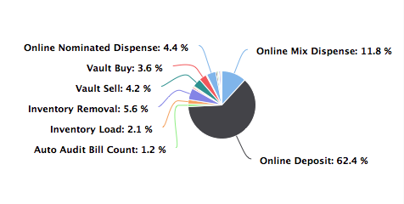

Pie chart since we are aleady

I think pie chart and Line chart should be display one below another so we can clearly display it.

Line chart changes from 1st page need to be implemented.

We need to create additional pie chart for

Pie chart for transactions by categoryfor range (Deposit/Withdrawal)

When there is no data we are displaying “No Any Transactions” in table. Message should be “No data available for selected period.”

**Analytics Management 🡪File Processing View**

Line chart need to increase in size (horizontally)

For Pie chart, if there is no data then we just display No data available (do not display chart).

Pie chart needs to be larger (Remove text from the pie chart and when user move mouse over particular pie then we will display its category.)

Pie Charts

Pie chart should show branch distribution.

We need to display following data into table format:

Sr No

Branch Name

File Date

File received for processing

File processed

No of Errors

No of transactions

No of deposits

No of Withdrawals

No of reports

No of Automix Settings

No of Bill Activity Report

No of Bill Adjustment Report

No of Bill Count Report

No of Bill History Report

No of Coin Inventory

No of Current Teller Transaction

No of History Report

No of Manager Setup

No of Net Cash Usage Report

No of Side Activity Report

No of Teller Activity Report

No of Valut Buy Report

Total Cash Deposited

Total Cash Requested

Total Cash Withdrawal

**Analytics Management 🡪Error/WarningView**

Need to create this view

**DEALER (ADMIN)**

Dashboard will not have “Unidentified Messages”

Dashboard will not have “No of Transactions” instead of this we will have no of clients.

Dashboard default should be last 7 days.

Ticketsarea needs to be expanded onto dashboard page and Tab should be on left side not on right.

If no active ticket then it shows message “No any tickets”, please change it to “No new ticket.”

<http://demo.securemetasys.com/dynalitics/dealers>

Please make sure all phone numbers are formatted

We should make url more readable. Since this is user related we should make sure that it shows users in it. Companies at end looks weird. I think url should be like (<http://demo.securemetasys.com/dynalitics/dealer_name/users>)

<http://demo.securemetasys.com/dynalitics/dealers/add>

We should make url more readable. Since this is user related we should make sure that it shows users in it. Companies at end looks weird. I think url should be like (<http://demo.securemetasys.com/dynalitics/dealer_name/users>)

We should remove “Address, Country, State, city and zip field”

Remove Membership

Assign Clients area is being overlapped so cannot be selected. Once above fields are removed we can moved client over right side. Add some extra space at bottom so scrolling down can solve issue.

<http://demo.securemetasys.com/dynalitics/companies>

Remove dealer dropdown

Remove dealer name from table

In table, No of Users should be No of support users.

<http://demo.securemetasys.com/dynalitics/companies/view/MTMxMzMxMzE%3D>

Dealer name doesn’t required

Email need to organize so it will be in one line

Remove Membership, Added On, Last Login

From branches table data,

Sr No can be “Sr.\nNo.” So it wont take that much space.

Remove country

Add support engineer name(s)

We don’t need company user data here, instead of that we will display list of dealer’s support engineer.

Columns should be:

Sr. No.

Branch Name

Support Engineer Name

Email

Phone

Status

Last Login

Branch Name will be link when user clicks on it, it will take user to branch detail page. I will provide more info later.

Support Engineer Name will be link, when admin clicks on it will take user to User Detail page.